**CAT 2, DUE 11 March 2021**

**NEW DEADLINE OOB MON 15th MARCH 2021**

1. Find the transition matrix from the transition diagram below (5 marks)

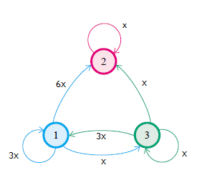

1. The number of the lions y=1, 2, 3 … breaking out of a Nairobi national park within the last one month follow the distribution $f\left(θ\right)=θ{(1-θ)}^{y-1}; y=1,2,3.. . ;0<θ<1.$

Find the Jeffrey’s prior distribution of $θ$ and hence or otherwise its posterior distribution. (10 marks)

1. Find the long term trend of the transition matrix (5 Marks)

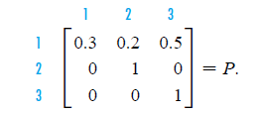

1. Suppose that 1 in 200 people in a population carry a certain gene. A test for the gene has been developed such that 90% of those who carry the gene test positively and 99% of those who do not carry the gene test negatively. If you test negative, what is the probability that you carry the gene? If you test positive, what is the probability that you do not carry the gene (5 marks)
2. Briefly describe Gibbs sampler for parameters $θ_{1}$, $θ_{2}$, and ${ θ}_{3}$, with joint distribution $p({y|θ}_{1}$, $θ_{2},θ_{3})$ (5 marks)